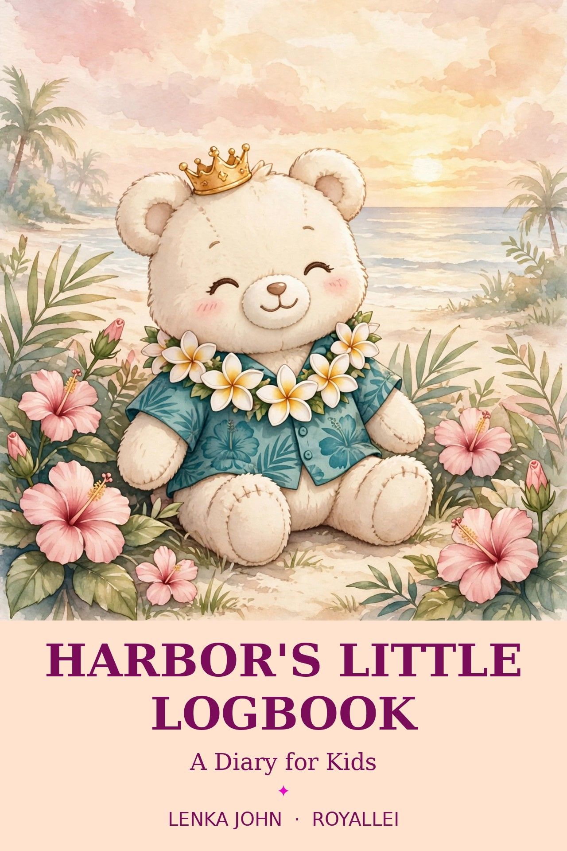
ROYALLEI
Harbor’s Little Logbook
A Diary for Kids
✦
For every heart finding its way home.

LENKA JOHN
royallei.com
© 2026 Lenka John. All rights reserved.
This Logbook Belongs To

My name is
________________________________
I am ______ years old.
My favorite color is ____________________.

If you find this logbook, please bring it back to me. Harbor and I thank you!
A Letter from Harbor
Aloha, friend! I am Harbor, the little plush from the harbor.
I wear a teal aloha shirt, a lei of plumeria flowers, and a gold crown that is a tiny bit too big.
Every evening, I climb the lighthouse stairs and light the lamp, so every boat can find its way home.
Now I have a new job, too — sitting beside you while you write and draw your days.
You do not have to be big to be brave. You only have to shine, a little bit, every single day.
Tell me about your sunny days, your rainy days, and your rainbow days. I want to hear them all.
I will be right here on every page, cheering for you.
Ready? Push up your crown, pick up your pencil, and let’s begin!
With aloha,
Harbor
How to Use Your Logbook
For You
• Pick the weather that matches your heart today.
• Write one good thing — big or small, it counts.
• Draw your day in the big box.
• Read Harbor’s words at the bottom of the page. He saved them just for you.
• On Fridays, color your stars!
For Grown-Ups
Read along with your child, or let them explore on their own. There are no wrong answers in this logbook. Some days, the weather in a child’s heart is stormy — that is a fine page, too. All Harbor asks is honesty, kindness, and a little bit of shine.
Day 1
Date: ____________________
The Weather in My Heart:
○ Sunny ○ Cloudy ○ Rainy ○ Stormy ○ Rainbow
One Good Thing About Today
__________________________________________________________
__________________________________________________________
__________________________________________________________
Draw Your Day
Harbor says: “Small lights still matter. Your light matters too.”
Day 2
Date: ____________________
The Weather in My Heart:
○ Sunny ○ Cloudy ○ Rainy ○ Stormy ○ Rainbow
One Good Thing About Today
__________________________________________________________
__________________________________________________________
__________________________________________________________
Draw Your Day
Harbor says: “You are seen, and you are loved.”
Day 3
Date: ____________________
The Weather in My Heart:
○ Sunny ○ Cloudy ○ Rainy ○ Stormy ○ Rainbow
Nalu asks: What made you laugh today?
__________________________________________________________
__________________________________________________________
__________________________________________________________
Draw Your Day
Harbor says: “Saying aloha means: I see you, and I am glad you are here.”
Day 4
Date: ____________________
The Weather in My Heart:
○ Sunny ○ Cloudy ○ Rainy ○ Stormy ○ Rainbow
One Good Thing About Today
__________________________________________________________
__________________________________________________________
__________________________________________________________
Draw Your Day
Harbor says: “A kind heart is the best crown of all.”
Day 5
Date: ____________________
The Weather in My Heart:
○ Sunny ○ Cloudy ○ Rainy ○ Stormy ○ Rainbow
One Good Thing About Today
__________________________________________________________
__________________________________________________________
__________________________________________________________
Draw Your Day
Color Your Stars
☆ ☆ ☆ ☆ ☆
Harbor says: “Slow is okay. Honu swims slowly, and he always gets home.”
Day 6
Date: ____________________
The Weather in My Heart:
○ Sunny ○ Cloudy ○ Rainy ○ Stormy ○ Rainbow
Honu says: What was slow and nice today?
__________________________________________________________
__________________________________________________________
__________________________________________________________
Draw Your Day
Harbor says: “Helping a friend makes your own heart feel bigger.”
Day 7
Date: ____________________
The Weather in My Heart:
○ Sunny ○ Cloudy ○ Rainy ○ Stormy ○ Rainbow
One Good Thing About Today
__________________________________________________________
__________________________________________________________
__________________________________________________________
Draw Your Day
Harbor says: “Brave does not mean big. Brave means staying and shining anyway.”
My Week with Harbor
Week 1
Three Things I Liked This Week
1.
__________________________________________________________
__________________________________________________________
2.
__________________________________________________________
__________________________________________________________
3.
__________________________________________________________
__________________________________________________________
My Week in One Picture
Day 8
Date: ____________________
The Weather in My Heart:
○ Sunny ○ Cloudy ○ Rainy ○ Stormy ○ Rainbow
One Good Thing About Today
__________________________________________________________
__________________________________________________________
__________________________________________________________
Draw Your Day
Harbor says: “Home is the people who love you.”
Day 9
Date: ____________________
The Weather in My Heart:
○ Sunny ○ Cloudy ○ Rainy ○ Stormy ○ Rainbow
Lani sings: What was the best sound today?
__________________________________________________________
__________________________________________________________
__________________________________________________________
Draw Your Day
Harbor says: “Your song matters. Lani’s little song wakes the whole harbor.”
Day 10
Date: ____________________
The Weather in My Heart:
○ Sunny ○ Cloudy ○ Rainy ○ Stormy ○ Rainbow
One Good Thing About Today
__________________________________________________________
__________________________________________________________
__________________________________________________________
Draw Your Day
Harbor says: “Even on a rainy day, your light can shine.”
Day 11
Date: ____________________
The Weather in My Heart:
○ Sunny ○ Cloudy ○ Rainy ○ Stormy ○ Rainbow
Nalu asks: Who did you play with today?
__________________________________________________________
__________________________________________________________
__________________________________________________________
Draw Your Day
Harbor says: “A wobbly start is still a start. Pat, pat, pat — keep going!”
Day 12
Date: ____________________
The Weather in My Heart:
○ Sunny ○ Cloudy ○ Rainy ○ Stormy ○ Rainbow
One Good Thing About Today
__________________________________________________________
__________________________________________________________
__________________________________________________________
Draw Your Day
Color Your Stars
☆ ☆ ☆ ☆ ☆
Harbor says: “It is okay to feel stormy inside. Storms always pass.”
Day 13
Date: ____________________
The Weather in My Heart:
○ Sunny ○ Cloudy ○ Rainy ○ Stormy ○ Rainbow
Honu says: What felt calm and cozy today?
__________________________________________________________
__________________________________________________________
__________________________________________________________
Draw Your Day
Harbor says: “You do not have to be brave alone. Ask a friend to stand beside you.”
Day 14
Date: ____________________
The Weather in My Heart:
○ Sunny ○ Cloudy ○ Rainy ○ Stormy ○ Rainbow
One Good Thing About Today
__________________________________________________________
__________________________________________________________
__________________________________________________________
Draw Your Day
Harbor says: “The light is shining. So are you.”
My Week with Harbor
Week 2
Three Things I Liked This Week
1.
__________________________________________________________
__________________________________________________________
2.
__________________________________________________________
__________________________________________________________
3.
__________________________________________________________
__________________________________________________________
My Week in One Picture
Day 15
Date: ____________________
The Weather in My Heart:
○ Sunny ○ Cloudy ○ Rainy ○ Stormy ○ Rainbow
One Good Thing About Today
__________________________________________________________
__________________________________________________________
__________________________________________________________
Draw Your Day
Harbor says: “When your crown slips, just push it back up and smile.”
Day 16
Date: ____________________
The Weather in My Heart:
○ Sunny ○ Cloudy ○ Rainy ○ Stormy ○ Rainbow
Nalu asks: What was the silliest thing today?
__________________________________________________________
__________________________________________________________
__________________________________________________________
Draw Your Day
Harbor says: “Kind words are like flowers. They make every place prettier.”
Day 17
Date: ____________________
The Weather in My Heart:
○ Sunny ○ Cloudy ○ Rainy ○ Stormy ○ Rainbow
One Good Thing About Today
__________________________________________________________
__________________________________________________________
__________________________________________________________
Draw Your Day
Harbor says: “Being small is not the same as being unimportant.”
Day 18
Date: ____________________
The Weather in My Heart:
○ Sunny ○ Cloudy ○ Rainy ○ Stormy ○ Rainbow
Lani sings: What made your heart sing today?
__________________________________________________________
__________________________________________________________
__________________________________________________________
Draw Your Day
Harbor says: “A good day is worth writing down. A hard day is worth sharing.”
Day 19
Date: ____________________
The Weather in My Heart:
○ Sunny ○ Cloudy ○ Rainy ○ Stormy ○ Rainbow
One Good Thing About Today
__________________________________________________________
__________________________________________________________
__________________________________________________________
Draw Your Day
Color Your Stars
☆ ☆ ☆ ☆ ☆
Harbor says: “Even lighthouse keepers rest. Rest helps your light shine again.”
Day 20
Date: ____________________
The Weather in My Heart:
○ Sunny ○ Cloudy ○ Rainy ○ Stormy ○ Rainbow
One Good Thing About Today
__________________________________________________________
__________________________________________________________
__________________________________________________________
Draw Your Day
Harbor says: “You belong, just as you are.”
Day 21
Date: ____________________
The Weather in My Heart:
○ Sunny ○ Cloudy ○ Rainy ○ Stormy ○ Rainbow
One Good Thing About Today
__________________________________________________________
__________________________________________________________
__________________________________________________________
Draw Your Day
Harbor says: “Tell the truth about your day. Your logbook is a safe place.”
My Week with Harbor
Week 3
Three Things I Liked This Week
1.
__________________________________________________________
__________________________________________________________
2.
__________________________________________________________
__________________________________________________________
3.
__________________________________________________________
__________________________________________________________
My Week in One Picture
Day 22
Date: ____________________
The Weather in My Heart:
○ Sunny ○ Cloudy ○ Rainy ○ Stormy ○ Rainbow
Honu asks: What did you notice on your way today?
__________________________________________________________
__________________________________________________________
__________________________________________________________
Draw Your Day
Harbor says: “Small lights still matter. Your light matters too.”
Day 23
Date: ____________________
The Weather in My Heart:
○ Sunny ○ Cloudy ○ Rainy ○ Stormy ○ Rainbow
One Good Thing About Today
__________________________________________________________
__________________________________________________________
__________________________________________________________
Draw Your Day
Harbor says: “You are seen, and you are loved.”
Day 24
Date: ____________________
The Weather in My Heart:
○ Sunny ○ Cloudy ○ Rainy ○ Stormy ○ Rainbow
Nalu asks: What was the most fun thing today?
__________________________________________________________
__________________________________________________________
__________________________________________________________
Draw Your Day
Harbor says: “Home is the people who love you.”
Day 25
Date: ____________________
The Weather in My Heart:
○ Sunny ○ Cloudy ○ Rainy ○ Stormy ○ Rainbow
One Good Thing About Today
__________________________________________________________
__________________________________________________________
__________________________________________________________
Draw Your Day
Harbor says: “Slow is okay. Honu swims slowly, and he always gets home.”
Day 26
Date: ____________________
The Weather in My Heart:
○ Sunny ○ Cloudy ○ Rainy ○ Stormy ○ Rainbow
One Good Thing About Today
__________________________________________________________
__________________________________________________________
__________________________________________________________
Draw Your Day
Color Your Stars
☆ ☆ ☆ ☆ ☆
Harbor says: “The light is shining. So are you.”
Day 27
Date: ____________________
The Weather in My Heart:
○ Sunny ○ Cloudy ○ Rainy ○ Stormy ○ Rainbow
Lani asks: Who made you smile today?
__________________________________________________________
__________________________________________________________
__________________________________________________________
Draw Your Day
Harbor says: “Even on a rainy day, your light can shine.”
Day 28
Date: ____________________
The Weather in My Heart:
○ Sunny ○ Cloudy ○ Rainy ○ Stormy ○ Rainbow
One Good Thing About Today
__________________________________________________________
__________________________________________________________
__________________________________________________________
Draw Your Day
Harbor says: “Brave does not mean big. Brave means staying and shining anyway.”
My Week with Harbor
Week 4
Three Things I Liked This Week
1.
__________________________________________________________
__________________________________________________________
2.
__________________________________________________________
__________________________________________________________
3.
__________________________________________________________
__________________________________________________________
My Week in One Picture
Harbor’s Goodnight Blessing
May your heart feel safe and small worries grow quiet.
May kindness find you wherever you are.
May you remember that home can be the people who love you.
And may your own little light shine —
softly, bravely, and true.
Good night. Aloha.
My Favorite Pages
Which pages do you love the most? Write them here, so you can find them again.
My favorite page was Day ______ because:
__________________________________________________________
__________________________________________________________
My favorite page was Day ______ because:
__________________________________________________________
__________________________________________________________
My favorite page was Day ______ because:
__________________________________________________________
__________________________________________________________
My favorite page was Day ______ because:
__________________________________________________________
__________________________________________________________
My favorite page was Day ______ because:
__________________________________________________________
__________________________________________________________
My favorite page was Day ______ because:
__________________________________________________________
__________________________________________________________
For Grown-Ups
Harbor’s world began in a little gift shop beside a gentle Hawaiian harbor, in the storybook Hawaiian Harbor Comes to Life. Harbor is a small cream plush with a teal aloha shirt, a plumeria lei, and a gold crown that is always a little too big. With his friends — Honu the sea turtle, Nalu the crab with one bigger claw, and Lani the little bird — he learns that home is the people who love you, and that brave does not mean big.
This logbook gives children a small, steady ritual: naming the weather in their hearts, noticing one good thing, and drawing their day. There are no wrong answers here, and no grades. If your child wants to share a page, listen the way the kind lady in the story listened — with your whole heart. If a page stays private, that is fine, too. Even keepers of the light keep a few pages just for themselves.
Thank you for making room for small stories and small lights. May this little logbook help your child feel seen, welcomed, and loved — one day, one page, and one good thing at a time.

Royallei · royallei.com · Lenka John

