ROYALLEI
PONO AND ALOHA
♡
A 5-Day Devotional Journal
Living in Balance, Loving with Aloha
A gentle journey toward integrity, compassion, and peace.
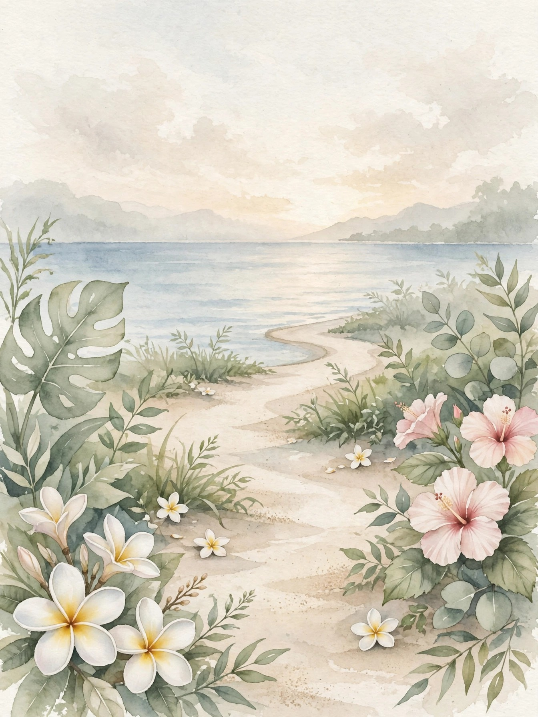
ROYALLEI.COM

Before you begin

A Gentle Note Before You Begin
This journal is designed for personal reflection, encouragement, and spiritual support. It is not a substitute for professional mental-health care, diagnosis, or treatment. If anxiety, relationship distress, or difficult emotions feel overwhelming or interfere with daily life, consider reaching out to a qualified mental-health professional for additional support.

How to Use This Journal
Move at your own pace. You can complete one day at a time, return to a prompt later, or simply sit with a prayer or affirmation that speaks to you. There is no perfect way to practice. Let honesty, compassion, and patience guide you.
A Grounding Reminder
This journal does not promise a perfectly balanced life. Its deeper invitation is to practice returning — to honesty, to kindness, and to love — one small step at a time, until balance and aloha become a way of walking through the world.

Contents
Welcome to Your Journey
Day 1 — Aloha Begins Within
Day 2 — Pono — Living in Balance
Day 3 — Aloha for Others
Day 4 — Pono in Hard Moments
Day 5 — Walking in Pono and Aloha
Bonus — My Pono and Aloha Affirmation Collection
My Five-Day Transformation
My Final Devotional — I Walk in Pono and Aloha
With Love

Welcome

Welcome to Your Journey
Dear Heart,
There is a Hawaiian way of living that holds two beautiful truths together. Pono means living in a way that is right and balanced — doing what is honest, keeping your life in alignment, and walking with integrity. Aloha means love in its fullest form — compassion, kindness, patience, and a heart open to others.
You do not have to choose between them. A life of pono makes room for aloha, and a life of aloha is kept honest by pono. Together, they become a way of walking through the world: grounded and gentle, strong and kind.
This devotional journal was created to help you practice both, one day at a time. Over the next five days, you will explore:
- Aloha Begins Within.
- Pono — Living in Balance.
- Aloha for Others.
- Pono in Hard Moments.
- Walking in Pono and Aloha.
Each day includes an intention, a devotional reflection, a spiritual reminder, Scripture, affirmations, journal prompts, a personal prayer, and a daily declaration.
You do not have to complete everything perfectly. Move slowly. Take a deep breath — ha, the breath of life — and let these pages become a peaceful place where you can meet yourself honestly and with compassion.
You can live with integrity and still be tender. You can love others deeply and still honor yourself. You can walk in balance and in love, at the same time.
Welcome to the journey.

DAY 1

Aloha Begins Within
Receiving Love Before Giving It
TODAY'S INTENTION
I allow myself to receive love before I try to give it away.

Devotional Reflection
Aloha is often thought of as something we give. We pour ourselves out for others, we show up, we care, we carry. But aloha must also be something we receive. A heart that never rests in love will eventually run dry, no matter how generous it is.
Today, you are invited to turn that love inward for a little while. You do not have to earn rest. You do not have to prove your worth before you are kind to yourself. The same love you offer so freely to others is meant for you too.
Sometimes receiving love feels unfamiliar. You may be used to being the strong one, the helper, the one who holds everything together. Letting yourself be held — by God, by grace, by quiet moments of care — can feel strange at first. But it is not selfish. It is how love is renewed.
When you allow yourself to be loved, you do not love others less. You love them from a fuller place. A heart at rest gives without resentment. A heart that knows it is loved does not need to chase love to feel worthy of it.
Today, practice receiving. Sit with a kind word instead of brushing it aside. Accept help without apologizing for needing it. Believe, even for a moment, that you are already worthy of the love you give so freely away.
Spiritual Reminder
You do not have to earn love before you receive it. Love is the starting place, not the reward.

Scripture for Reflection
"We love because He first loved us." — 1 John 4:19
Affirmations
- I am worthy of love exactly as I am.
- I allow myself to receive care without guilt.
- I do not have to earn rest or kindness.
- My heart deserves the same compassion I give others.
- I am loved before I do anything at all.
- Receiving love makes my giving stronger, not weaker.
DAY 1 • JOURNAL REFLECTION
- What makes it hard for me to receive love or care from others?

- When did I last let someone be kind to me without apologizing or returning the favor right away?

- What would change if I believed I was already worthy of love?

- How can I speak to myself with the same tenderness I offer others?

- What is one gentle way I can let myself be cared for today?

DAY 1 • PRAYER & DECLARATION
Today's Prayer
God,
Thank You for loving me first, before I did anything to deserve it. Teach me to receive that love instead of always trying to earn it. Help me rest in the truth that I am already worthy of care, kindness, and grace. When I am tempted to run myself dry for others, remind me that a rested heart loves better. Fill me today, so that what I give comes from fullness and not from emptiness.
Amen.
Daily Declaration
I can receive love without guilt and without earning it. I am worthy of the same aloha I give to others. Today, I let myself be loved, and I let that love renew me.

What I Want to Carry Forward

DAY 2

Pono — Living in Balance
Integrity in the Small Things
TODAY'S INTENTION
I choose what is right and balanced, even in small things.

Devotional Reflection
Pono is often described as righteousness, but it is also something quieter and more everyday: balance. A pono life is a life in alignment — where what you believe, what you say, and what you do are not pulling in different directions.
Balance rarely comes from one big decision. It comes from small, honest choices repeated daily. Keeping a promise to yourself. Saying no when you mean no. Telling the truth kindly instead of saying what is easiest. Resting when your body asks for rest instead of pushing past it again.
When life feels out of balance, it is usually not because everything is wrong. It is because one part of life has grown too heavy while another has been neglected. Perhaps work has crowded out rest. Perhaps caring for others has crowded out caring for yourself. Perhaps the noise of everyone else's needs has drowned out your own quiet knowing.
Today, take an honest look at where you are. Not with judgment, but with gentleness. Where is the weight uneven? What small adjustment would bring a little more balance back? Pono does not demand perfection. It asks only for honesty and one next right step.
You do not have to fix your whole life today. You only have to notice where alignment has slipped and choose one small thing that sets it right. That is how balance returns — quietly, one choice at a time.
Spiritual Reminder
Balance is not found by doing more. It is found by choosing what is right, one small step at a time.

Scripture for Reflection
"He has shown you, O mortal, what is good. And what does the Lord require of you? To act justly and to love mercy and to walk humbly with your God." — Micah 6:8
Affirmations
- I choose honesty in small things.
- My life can come back into balance one step at a time.
- I honor my limits as well as my commitments.
- I do not have to be perfect to live with integrity.
- I listen to the quiet knowing inside me.
- Balance is a practice, not a destination.
DAY 2 • JOURNAL REFLECTION
- Where does my life feel out of balance right now?

- What part of my life have I been neglecting while another part grows heavy?

- What is one small, honest choice I can make today?

- When do I say yes while my heart is saying no?

- What does a balanced day look like for me, in real life?

DAY 2 • PRAYER & DECLARATION
Today's Prayer
God,
Show me where my life has drifted out of balance. Give me the honesty to see it clearly and the courage to make one small adjustment. Help me act justly, love mercy, and walk humbly — not perfectly, but sincerely. Teach me to keep promises to myself as faithfully as I keep them to others. Bring my choices, my words, and my heart back into alignment with You.
Amen.
Daily Declaration
I do not have to fix everything at once. I choose one honest step toward balance today. I live with integrity in small things, and that is enough.

What I Want to Carry Forward

DAY 3

Aloha for Others
Compassion in Action
TODAY'S INTENTION
I let love become something I do, not only something I feel.

Devotional Reflection
Aloha is more than a feeling. Feelings come and go, but aloha is a practice — patience when someone is difficult, kindness when no one is watching, forgiveness when it would be easier to stay angry, and generosity that expects nothing in return.
Loving others well does not mean losing yourself. True aloha never asks you to disappear. It asks you to show up as your whole self and to make room for someone else to do the same. You can be kind and still have boundaries. You can be generous and still say no. You can forgive and still protect your peace.
Think of someone in your life who needs aloha today. It may not be a grand gesture. It may be a listening ear, a meal, a message that says "I am thinking of you," or simply refusing to speak harshly when you are tired. Small kindnesses are not small to the person receiving them.
There is also a quieter kind of aloha: the way you speak about people when they are not in the room, the patience you show a stranger, the grace you extend to someone who is struggling. The world is shaped by these ordinary moments more than by any single great act.
Today, let your love take form. Choose one person, one moment, one act of compassion, and let aloha move from your heart into your hands.
Spiritual Reminder
Love is not only felt. It is practiced — in patience, in kindness, and in the small choices of an ordinary day.

Scripture for Reflection
"Therefore, as God's chosen people, holy and dearly loved, clothe yourselves with compassion, kindness, humility, gentleness and patience." — Colossians 3:12
Affirmations
- My love is shown in what I do, not only in what I feel.
- I can be kind and still hold healthy boundaries.
- I choose patience, even when it is difficult.
- Small acts of compassion matter more than I know.
- I speak about others with grace, even when they are not listening.
- Aloha moves through me into the world around me.
DAY 3 • JOURNAL REFLECTION
- Who in my life could use a little aloha today?

- What is one small, concrete act of kindness I can offer?

- When is it hardest for me to be patient or compassionate?

- How can I love others without losing myself?

- What kind of person do I want to be in my everyday interactions?

DAY 3 • PRAYER & DECLARATION
Today's Prayer
God,
Clothe my heart with compassion, kindness, humility, gentleness, and patience. Show me who needs aloha from me today, and give me the willingness to act on it. Help me love in practical ways — in listening, in patience, in small kindnesses that cost me little but mean much. Teach me to love others fully without abandoning myself. Let my love be real, not just felt, but lived.
Amen.
Daily Declaration
Today, my love takes form. I choose one act of compassion, one moment of patience, one kindness. Aloha lives in what I do.

What I Want to Carry Forward

DAY 4

Pono in Hard Moments
Doing Right When It Is Difficult
TODAY'S INTENTION
I can do what is right and still protect my peace.

Devotional Reflection
Pono is easy to practice when life is calm. It becomes real in hard moments — when someone hurts you, when a boundary costs you approval, when doing the right thing means a difficult conversation, or when forgiveness feels far away.
Hard moments often tempt us in two directions. One is to abandon what is right in order to keep the peace — to stay silent, to agree when we disagree, to carry what is not ours. The other is to hold so tightly to being right that we lose compassion altogether. Pono lives in the middle: honest and kind at the same time.
Forgiveness belongs here too. Forgiving someone does not mean pretending nothing happened, and it does not mean letting them back into a place they have not earned. Forgiveness means releasing the grip that hurt has on your heart, so that someone else's choices no longer decide your peace. It is something you do for your own freedom as much as for theirs.
Boundaries are also pono. Saying "this is not okay with me" is not unkind. It is honest. A boundary spoken with respect protects both people — it keeps resentment from growing and it keeps the relationship truthful.
Today, if a hard moment is before you, you do not have to solve it perfectly. You only have to ask: what is the honest thing, and what is the kind thing? Often, they are the same thing. And when they seem different, choose the path that lets you stay whole and at peace.
Spiritual Reminder
Doing what is right does not require you to be harsh, and being kind does not require you to abandon the truth. Pono holds both.

Scripture for Reflection
"If it is possible, as far as it depends on you, live at peace with everyone." — Romans 12:18
Affirmations
- I can be honest and kind at the same time.
- Forgiveness frees my heart; it does not erase the truth.
- My boundaries are an act of integrity, not unkindness.
- I do not have to keep the peace by abandoning myself.
- I choose peace that is real, not peace that is pretended.
- I can do the right thing, even when it is hard.
DAY 4 • JOURNAL REFLECTION
- What hard moment is asking for pono from me right now?

- Where have I kept the peace by abandoning what I know is right?

- What does forgiveness mean to me, separate from reconciliation?

- What boundary do I need to speak with honesty and respect?

- How can I stay whole and at peace in this situation?

DAY 4 • PRAYER & DECLARATION
Today's Prayer
God,
Give me courage for the hard moments. When honesty costs me comfort, help me speak truth with kindness. When forgiveness feels impossible, loosen the grip of hurt on my heart at whatever pace I can manage. Teach me that boundaries are not walls against love but the shape that keeps love honest. Help me live at peace with others as far as it depends on me — and release what does not depend on me into Your hands.
Amen.
Daily Declaration
I can do what is right and still protect my peace. I speak honestly, I forgive freely, and I hold boundaries with respect. Today, I choose pono, even when it is hard.

What I Want to Carry Forward

DAY 5

Walking in Pono and Aloha
Carrying Both into Everyday Life
TODAY'S INTENTION
I carry balance and love into my ordinary days.

Devotional Reflection
The real test of any practice is not how it feels on a quiet morning with a journal in your lap. It is how it holds up on an ordinary Tuesday — in traffic, in a tense conversation, in a tired evening when patience is thin and old habits return.
Pono and aloha were never meant to stay on the page. They are meant to walk with you. Pono in the way you answer an email honestly instead of putting it off. Aloha in the way you greet the cashier, the way you speak to your family when you are tired, the way you forgive yourself for an imperfect day and begin again.
You will not practice them perfectly. Some days balance will slip. Some days love will feel thin. That does not mean you have failed. It means you are human, and the practice is still there waiting for you the next morning. Returning is part of the practice. Beginning again is part of the practice.
Look back over these five days. You have learned to receive love before giving it away. You have looked honestly at where your life needs balance. You have let love become action. You have faced hard moments with honesty and grace. None of that disappears because a day goes badly.
From here, the journey is simple, even if it is not always easy: notice when you drift, choose one small step back toward balance, and let love lead the way you take it. Walk gently. Walk honestly. Walk in pono and aloha.
Spiritual Reminder
The practice is not perfection. It is returning — again and again — to balance and to love.

Scripture for Reflection
"But the fruit of the Spirit is love, joy, peace, forbearance, kindness, goodness, faithfulness, gentleness and self-control." — Galatians 5:22-23
Affirmations
- I carry pono and aloha into ordinary days.
- Returning to the practice is part of the practice.
- I do not have to be perfect to live this way.
- My everyday choices shape the life I am building.
- I walk gently, honestly, and with love.
- Balance and love are mine to practice, one day at a time.
DAY 5 • JOURNAL REFLECTION
- How has my understanding of pono changed during these five days?

- How has my understanding of aloha changed?

- What does an ordinary day look like when I walk in both?

- What helps me return to balance and love when I drift?

- What is one daily practice I want to keep from this journal?

DAY 5 • PRAYER & DECLARATION
Today's Prayer
God,
Thank You for walking with me through these five days. Help me carry what I have learned into ordinary life — into kitchens and cars, conversations and quiet evenings. When I drift from balance, bring me back gently. When love feels thin, fill me again. Let the fruit of Your Spirit grow in me: love, joy, peace, patience, kindness, goodness, faithfulness, gentleness, and self-control. May my life become a quiet example of pono and aloha, one day at a time.
Amen.
Daily Declaration
I walk in pono and aloha. Not perfectly, but sincerely — one ordinary day at a time. I return when I drift, I love when it is hard, and I keep walking.

What I Want to Carry Forward

Bonus Section

My Pono and Aloha Affirmation Collection
Read these affirmations slowly each morning or before sleep.

Aloha for Myself
- I am worthy of love exactly as I am.
- I receive care without guilt.
- I speak to myself with tenderness.
- I rest without apologizing for it.
- My heart is a safe place to live.

Living Pono
- I choose what is right, even in small things.
- I keep my word to myself.
- I live in alignment with what I believe.
- I honor my limits.
- Balance returns one honest step at a time.

Aloha for Others
- I am patient with the people around me.
- I offer kindness without expecting return.
- I listen before I judge.
- I forgive in order to free my own heart.
- My love takes form in everyday actions.

Walking in Balance
- I can be strong and gentle at once.
- I protect my peace without closing my heart.
- I return to the practice whenever I drift.
- I walk humbly, honestly, and with love.
- Pono and aloha guide my days.

Reflection

My Five-Day Transformation
Complete this reflection after finishing the devotional.

Day 1 — Aloha Begins Within
One way I will let myself receive love:

Day 2 — Pono, Living in Balance
One small step toward balance I will take:

Day 3 — Aloha for Others
One act of compassion I will practice:

Day 4 — Pono in Hard Moments
One truth I will hold with honesty and grace:

Day 5 — Walking in Pono and Aloha
One promise I am making to myself:

My Final Devotional

I Walk in Pono and Aloha
Dear Heart,
You do not have to live pulled between being good and being kind, between standing firm and staying soft. Pono and aloha were never opposites. They belong together, like two hands holding the same life.
You can tell the truth and still be gentle. You can set a boundary and still love the person on the other side of it. You can rest without guilt and give without running dry. You can forgive without forgetting what you learned, and you can begin again as many times as you need to.
The life you are building does not need to be impressive. It needs to be honest. It needs to be kind. It needs to have room in it for you — your rest, your voice, your limits, your joy — as well as room for others.
So walk gently. Walk honestly. When you drift, return. When love feels thin, receive before you give. When a moment is hard, choose what is right and let kindness shape how you do it.
You are already on the path. Every small, honest, loving choice is a step further along it.
My Final Declaration
Aloha begins within me.
Pono keeps me in balance.
I love others without losing myself.
I do what is right, even when it is hard.
I return whenever I drift.
I walk gently, honestly, and with love.
I walk in pono and aloha.

♡
WITH LOVE
May these pages remind you that balance and love belong together.
May you become more comfortable receiving love, more honest in small things, more patient with others, and more peaceful in hard moments.
May you recognize that you can be strong without being harsh, tender without being powerless, and faithful without being perfect.
Your journey in pono and aloha begins with the way you care for yourself today.
Walk gently. Walk honestly. Walk in love.

© Royallei.com
PONO AND ALOHA • Royallei.com

